Sacha Romanovitch
CEO
Grant Thornton UK LLP
Grant Thornton House
Melton Street
Euston Square
London
NW1 2EP

Sunday, 29 November 2015

Dear Sacha Romanovitch

Stockport Council, fraud

I note from page 14 of Grant Thornton’s Audit findings for Stockport Council:
“Matters in relation to fraud – We have written to the Chair of the Audit Committee in relation to the risk of fraud. We have not been made aware of any material incident…..”

I would like to raise an issue with you which I have been trying week in week out with the Chief Executive, Leader, former Leader, Executive Councillors past and present and the current and previous Monitoring Officers for possibly seven years without any response whatsoever. I ask questions about it in council meeting and am banned as “vexatious” under the FOIA and EIR 2004, even though I have asked council meeting questions and not asked the questions under FOIA legislation. The Finance Director who like the above officers and senior councillors has a legal obligation to respond within 10 working days has not responded at all. There is no functioning Fraud and Financial Irregularities Policy at Stockport Council.

I will copy this letter to the Prime Minister and Chancellor of the Exchequer, as the current Leader of Stockport Council has publicly thrown down the gauntlet to the Prime Minister to meet her at No 10 to give her access to more money, so I think Mr Cameron and Mr Osborne might be interested in your response to this letter.
http://www.manchestereveningnews.co.uk/news/greater-manchester-news/greater-manchester-town-hall-leader-10442874

I am concerned that Stockport Council is one of the DevoManc councils, so surely with this increased level of involvement with the health service budget it is vital some sort of safeguards for public money are in place.

I am also concerned that the council has borrowed £100m for pothole repairs, more, I believe, than Glasgow.

I am concerned regarding the A6 MARR road scheme, started illegally on February 19th, presumably as a pre-election vote winner, when it shouldn’t have been started legally until mid-March 2015. Will that illegality void any insurance for the scheme? Who knows? I am concerned that they started the road scheme without the necessary Great Crested New licence in place, despite the risks of this, and have spent six months chasing 1200 great crested newts with plastic buckets at enormous expense. They have mis-calculated the sort of railway bridge they need necessitating a new planning application which was held in secret. How much is this railway bridge to cost? They can’t say. They are moving the oil pipeline which supplies fuel to Manchester Airport but aren’t able to find even one document on the subject for me under the FOIA or EIR 2004.

They are moving Stockport Market which has been around Castle Yard for 750 years. There are 7,000 signatures against it from local people so far. The market traders don’t want to move. They are borrowing yet another £7m to do this. Why? I doubt we will be given the details under the FOIA based on previous experience.

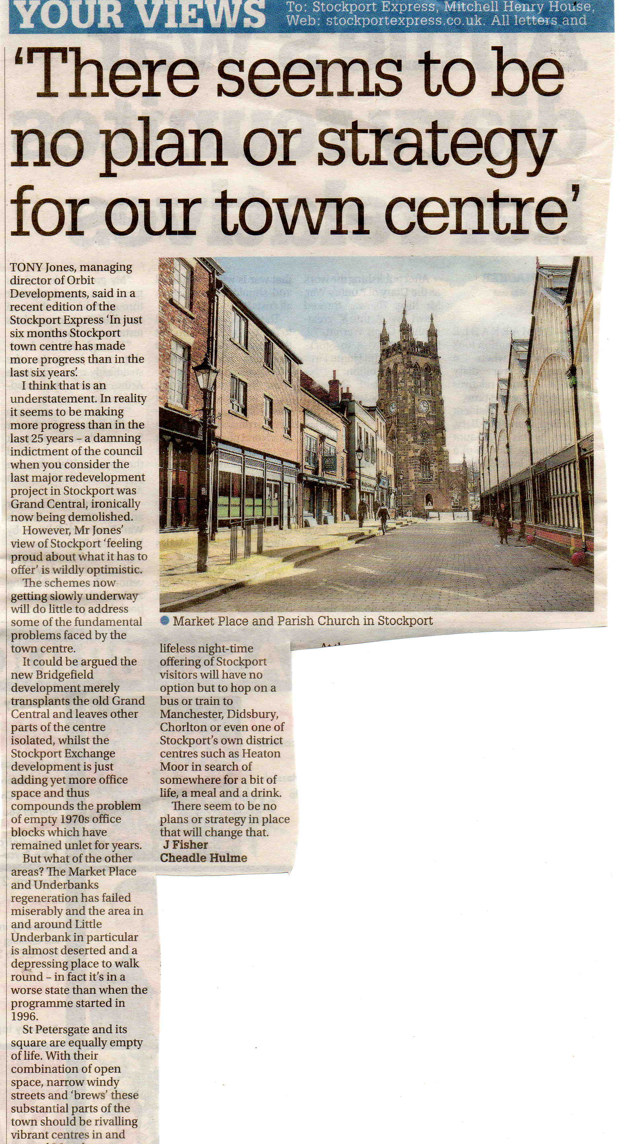
http://www.manchestereveningnews.co.uk/news/thousands-sign-petition-against-moving-10313756

This brings me to my main concern regarding fraud. The new toxic waste dump primary school at North Reddish, Stockport. Three excellent schools were closed, with a view to building housing on their existing, large sites and the proposal was to put a new primary school on a still gassing, former toxic waste dump. Local people didn’t want this. There are no letters in favour of the proposal and circa 1500 objections at planning. People didn’t want to lose their local open space as in the intervening years the tip has been grassed over and was a vital community asset. The Council’s own contamination expert admitted at public inquiry the tip was completely safe until disturbed.

The Council knew the site was contaminated, as they had refused three planning applications for housing in 1974 on those grounds, but they tried to pretend the site was completely clean. Local people and the local MP forced some sort of contamination investigations to be done on the site, but completely inadequate ones. I provided the Council with evidence the site was contaminated (a fact they already knew) but they banned me as “vexatious” for raising this issue. Because they didn’t carry out contamination investigations in accordance with BS 10175 as they claimed on a strict grid pattern, they were able to not look for contamination directly over the rubbish in-filled claypits, so they said the site was safe to build on. It wasn’t.

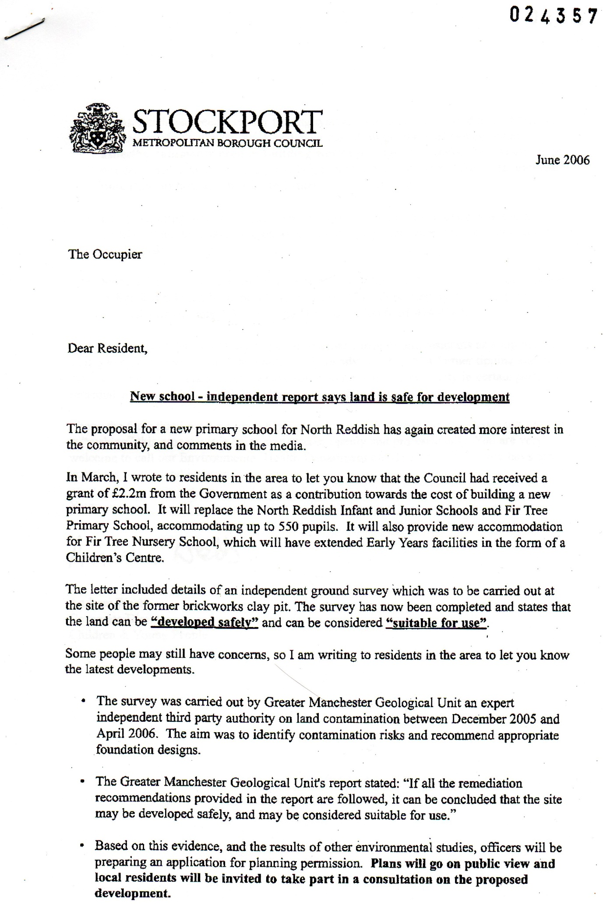

The remediation measures included planting prickly bushes to screen the children from lethal lead, arsenic and brown asbestos.
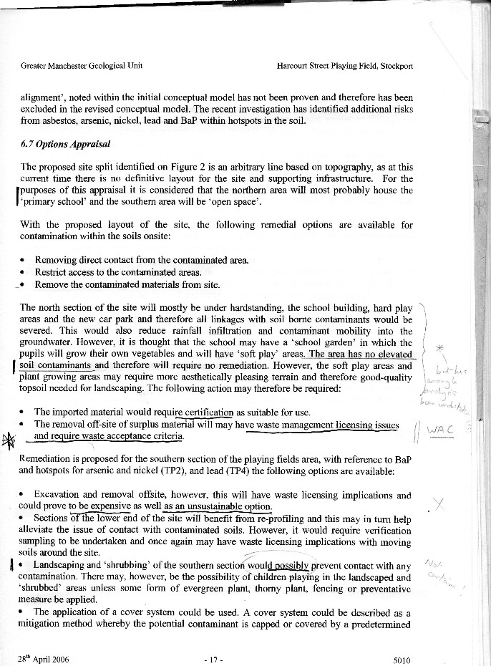

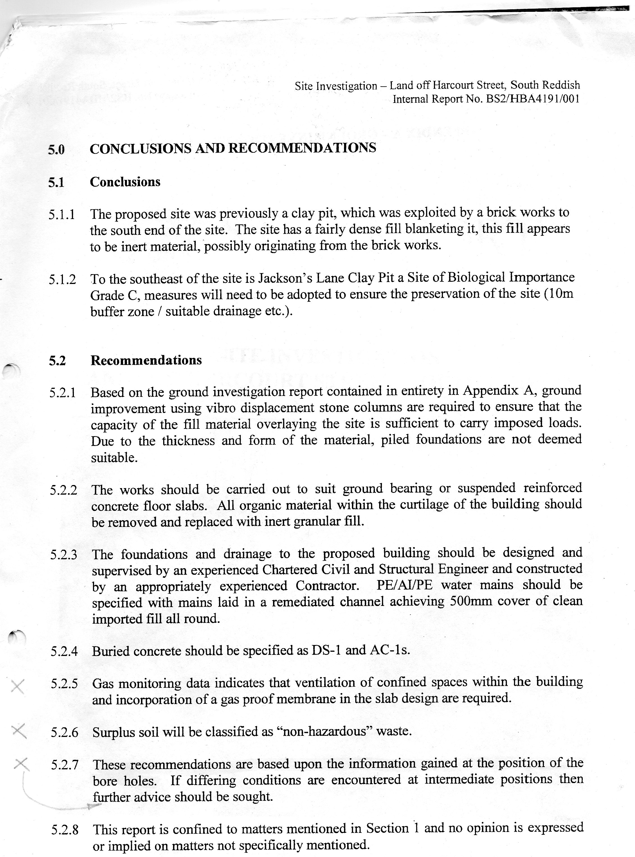
Surplus soil will be classified as “non-hazardous” waste.
I provide this information in case you think the massive increase in cost of this school was to deal with the toxic waste. It wasn’t. The cost rose from £5.5m in October 2005 to £10m shortly afterwards at a time when they were pretending this site was clean one. It wasn’t.

I went to the Environment Agency to show them the contamination evidence Stockport Council told me I was “vexatious” for providing. They told the Council not to decide the planning application on grounds of contamination. Stockport Council “forgot” to mention this to the Planning Committee.

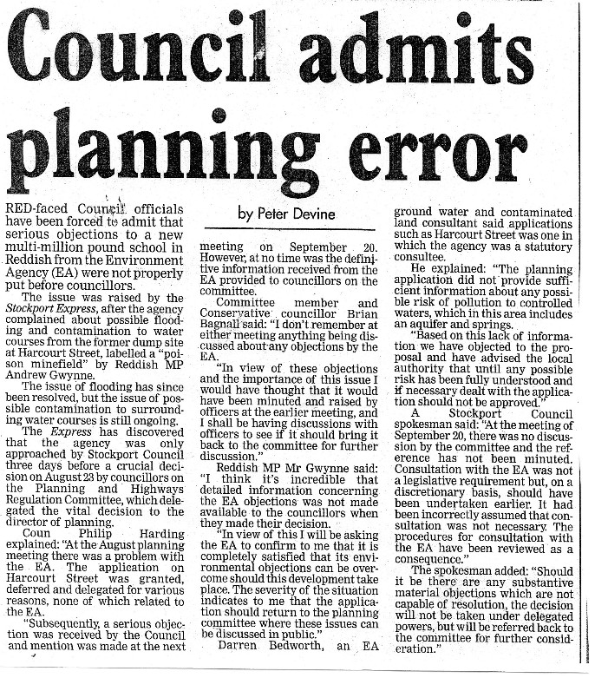
I objected to the diversion of a footpath from the site as I complained that the footpath might be being diverted into areas of contamination. For that public inquiry and for that inquiry only, Stockport Council finally carried out some sort of adequate contamination investigations and the entire site was found to be contaminated with lead, arsenic and brown asbestos.
No apology for me though, I was still deemed “vexatious” even though I had been right.

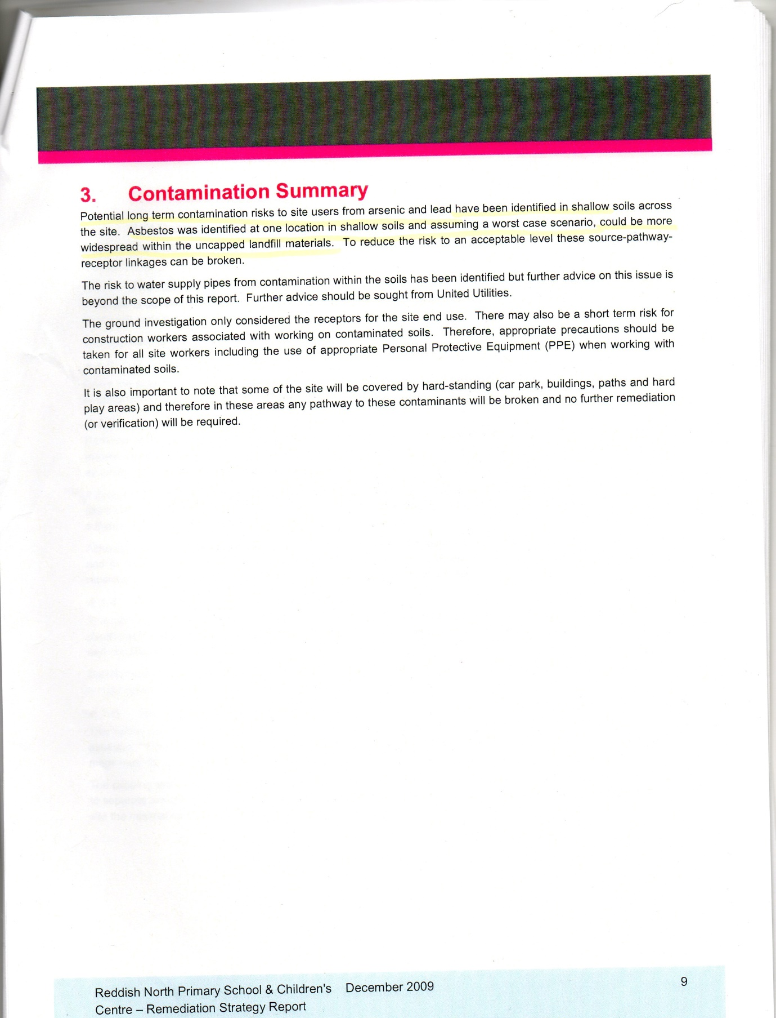

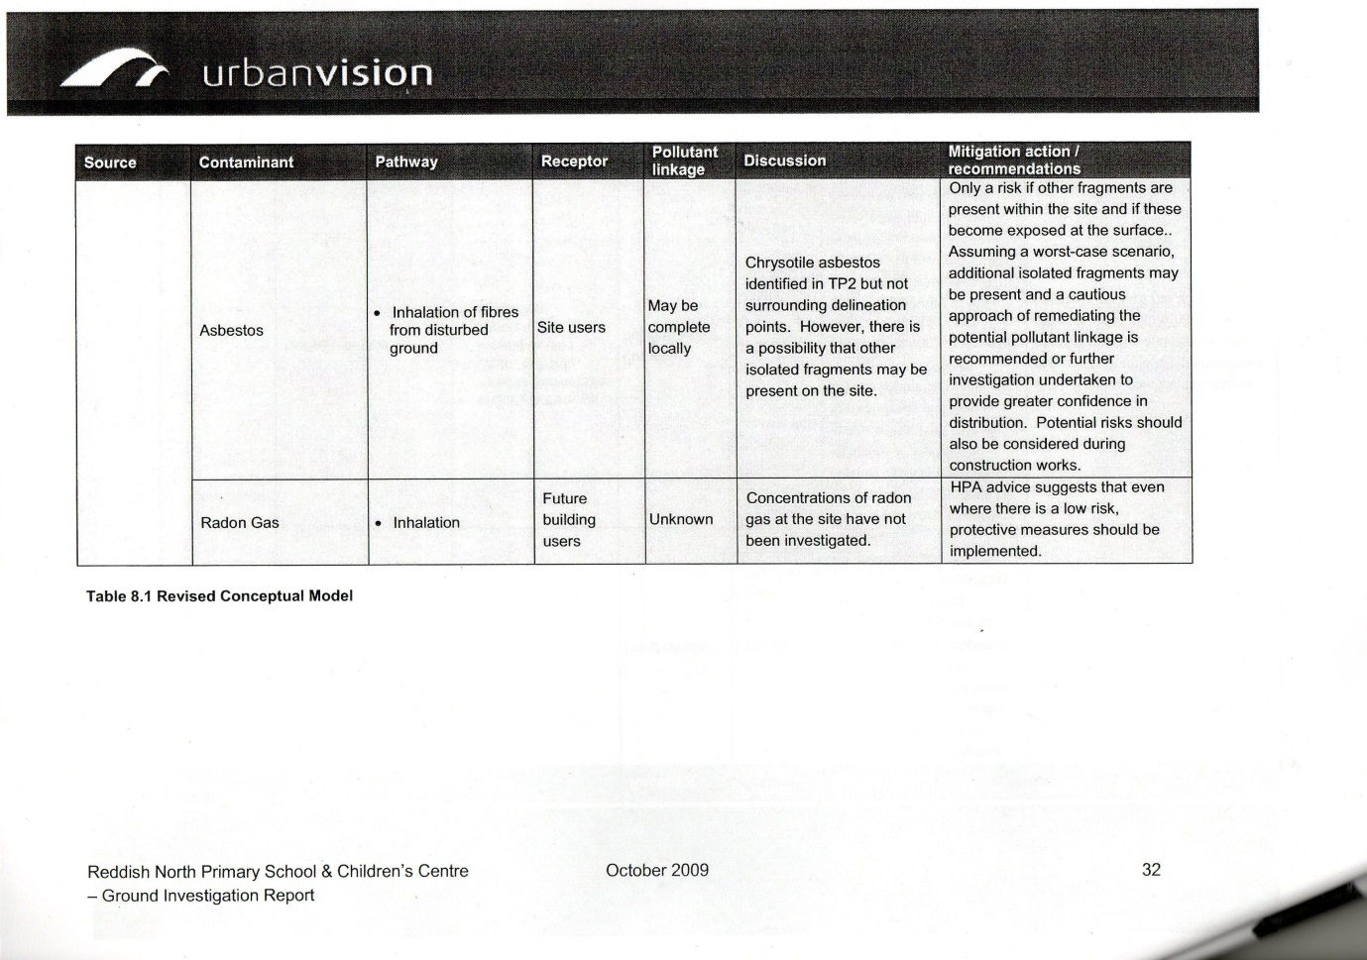
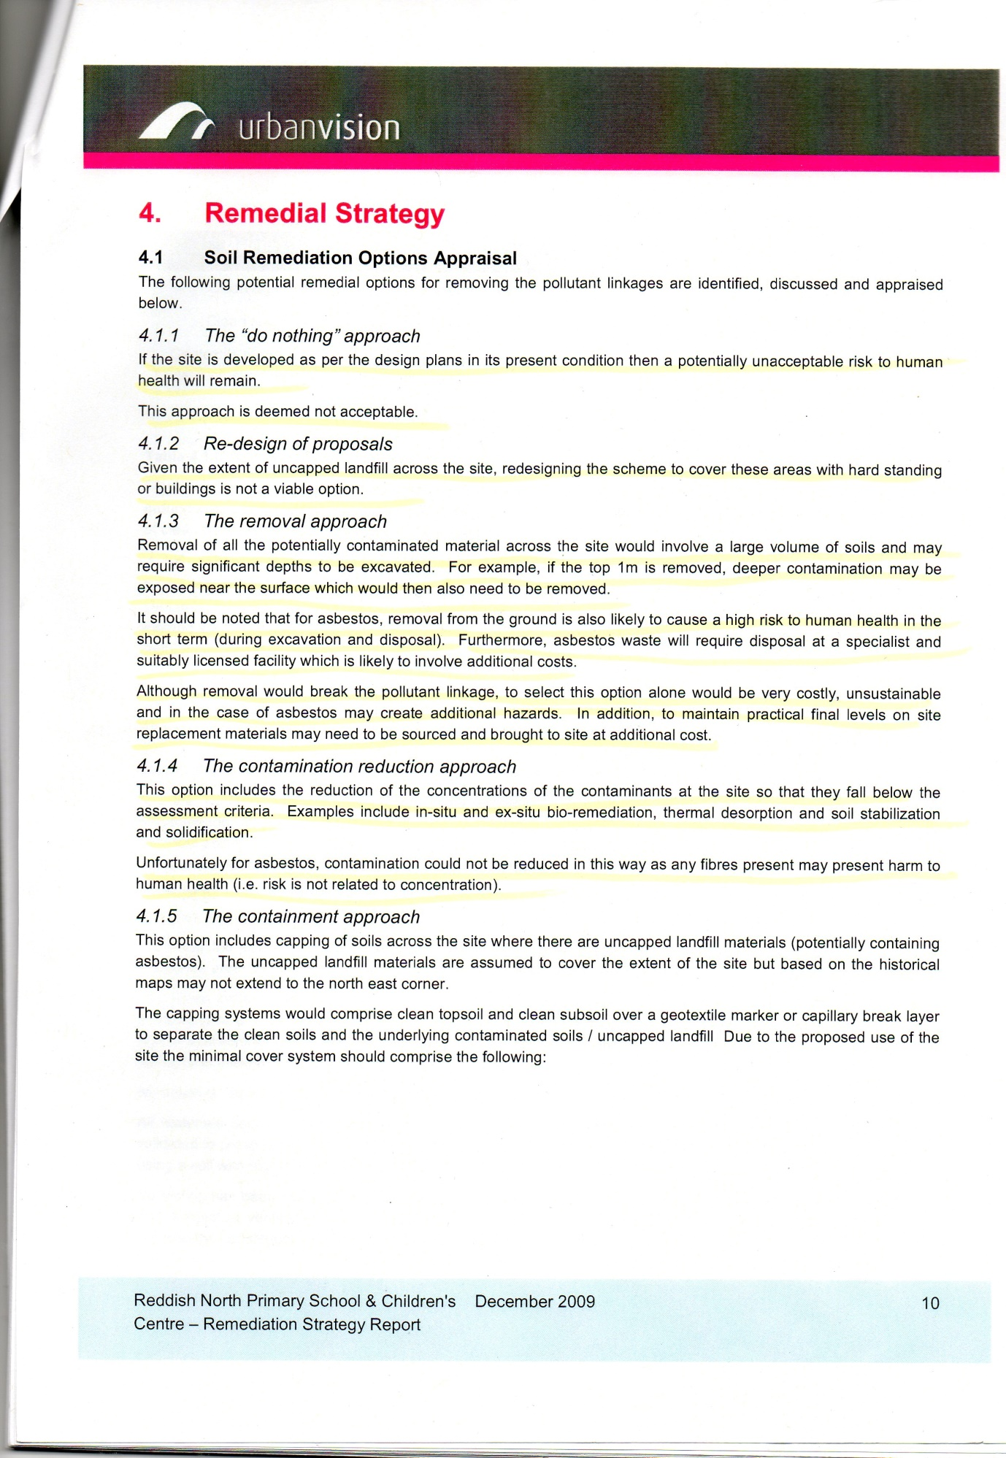

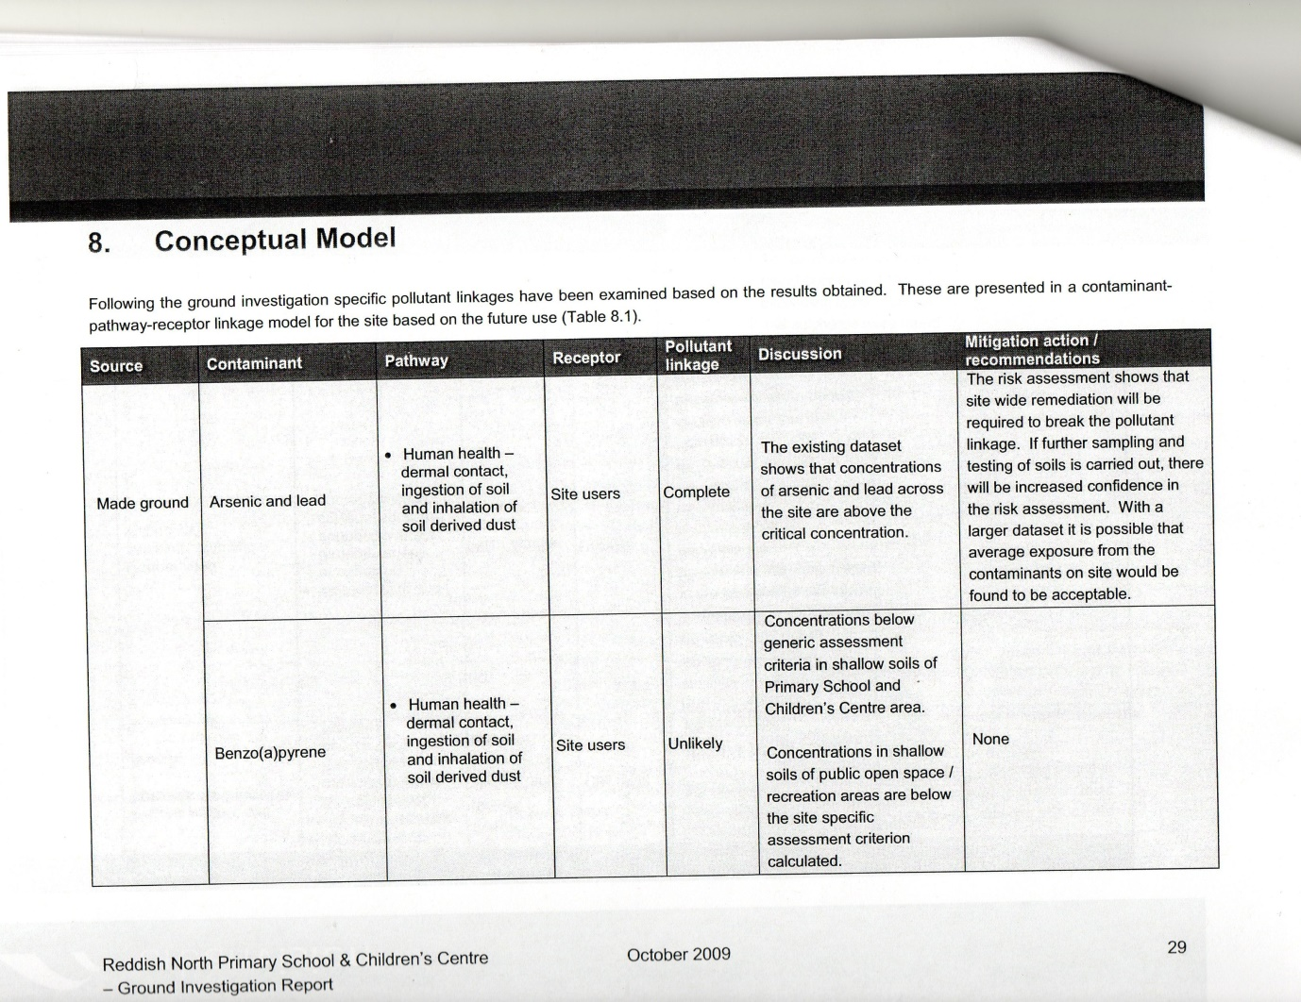
This brings me to further concerns from your report:
We are not aware of any significant incidences of non-compliance with relevant laws and regulations. As they were still claiming I was “vexatious” for asking FOIA and EIR 2004 questions even after the full facts were known, they are non-compliant with relevant laws.

I had raised the issue of traffic with senior council officers and senior councillors. Within weeks of the school opening the police complained to the council about the dangerous traffic situation created around the new school.

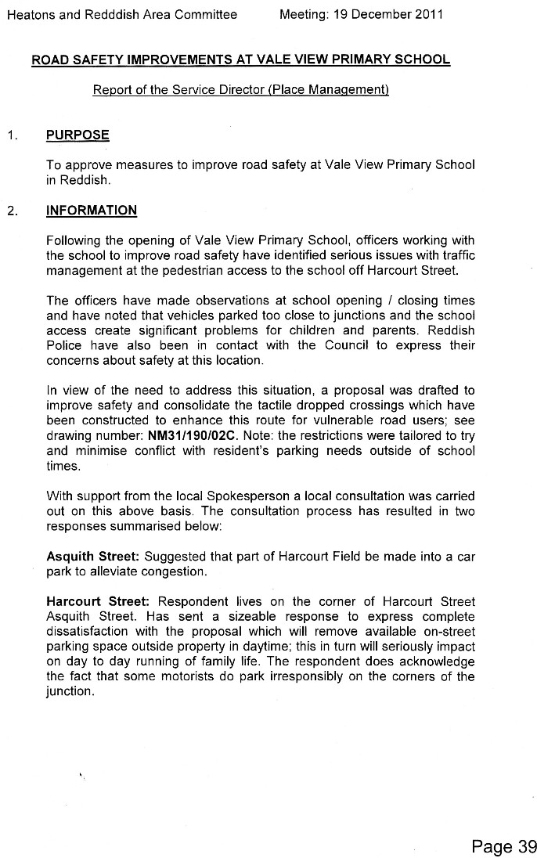

Despite this further evidence that I had been correct, they still brand me as “vexatious” for raising this issue of traffic dangers around the school. Again, this is non-compliance with relevant laws and regulations. The Council knows I am not being “vexatious” in raising this but maintains I am.

Furthermore, I told the Council they were building the school too small. Why build a new school too small? The birth rate in the area was rising sharply and not falling. Why not simply take the cheaper option of renovating the three existing schools, which was what local people wanted?

http://www.manchestereveningnews.co.uk/news/greater-manchester-news/council-bosses-to-spend-74m-on-building-695791

One year after the opening of the new school they talk about having to re-open the old one as well.
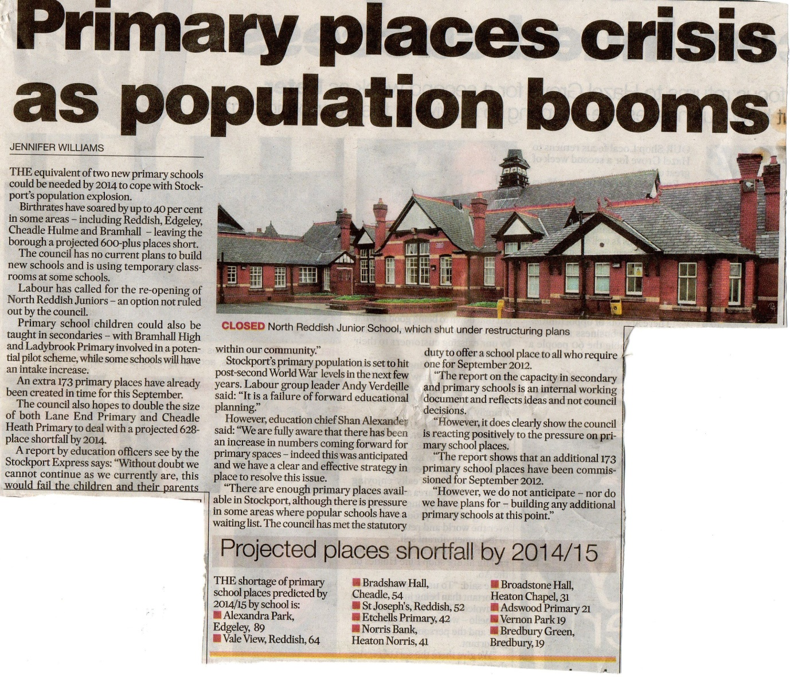
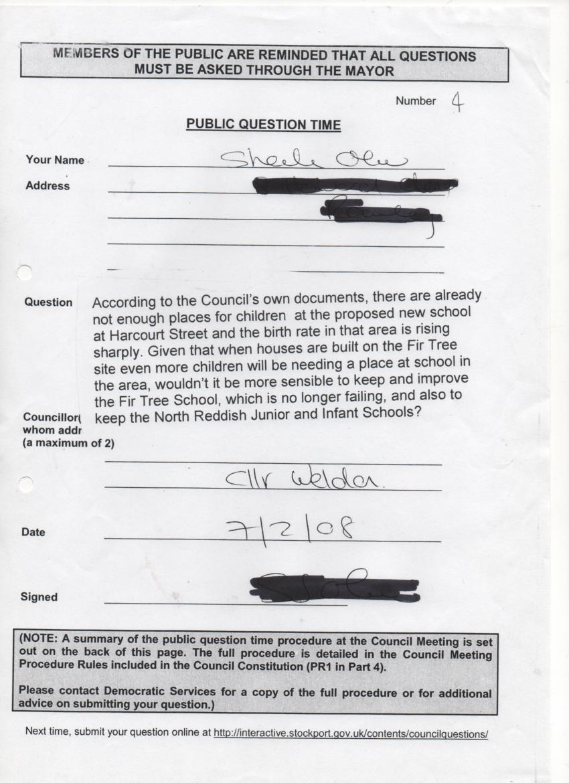
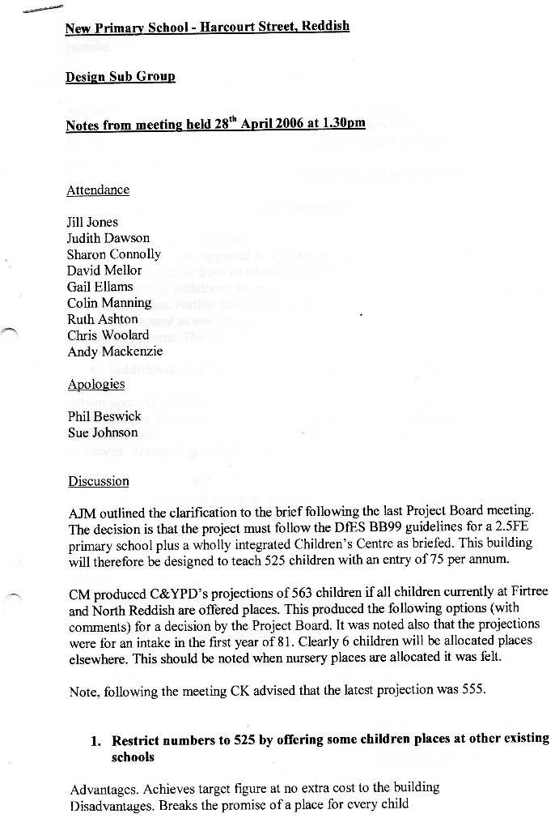

563 children need to attend and there is only room for 525. Why build it then. They claimed I was “vexatious” to even mention this. This again is non-compliance with relevant laws. It was not “vexatious” to ask this under the FOIA and EIR 2004 and they knew that at the outset.

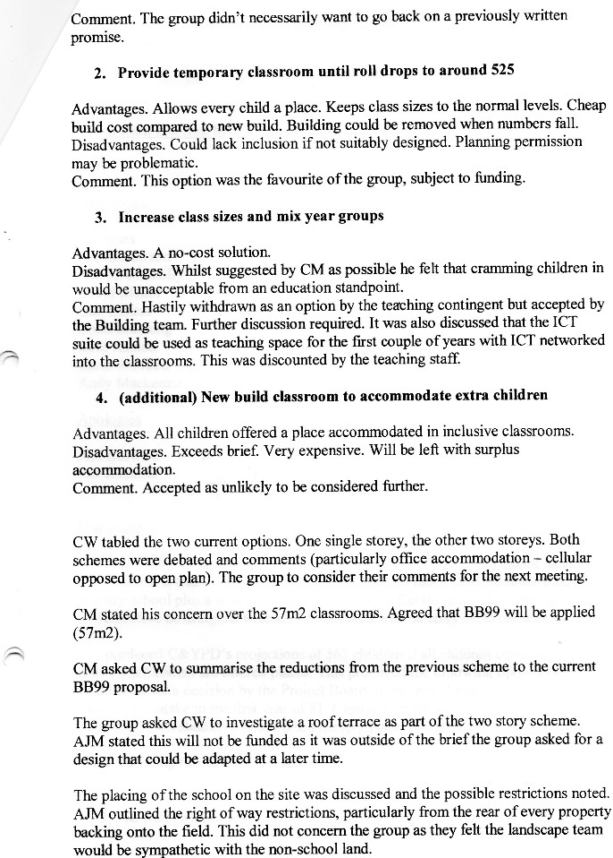
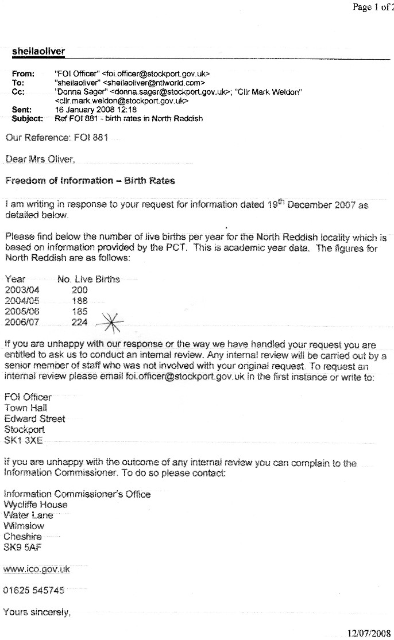
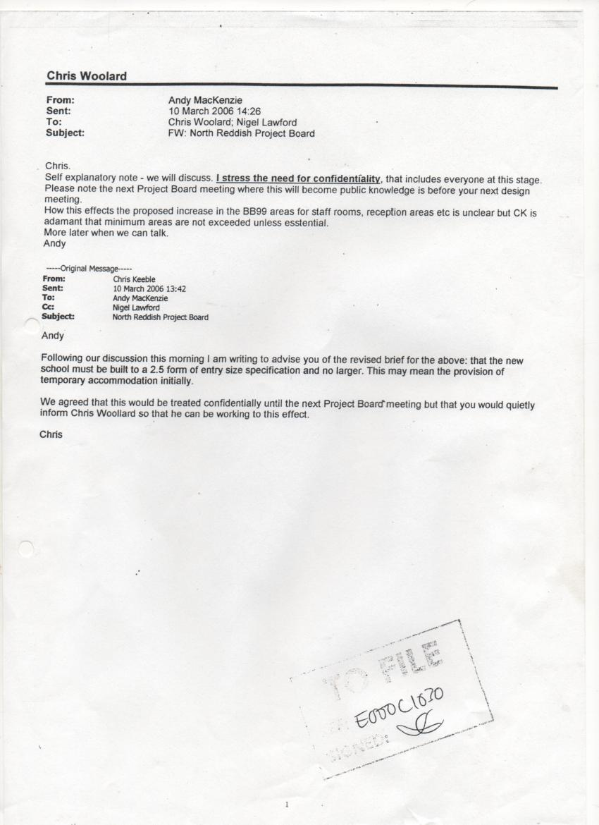

School not big enough – “I stress the need for confidentiality”.

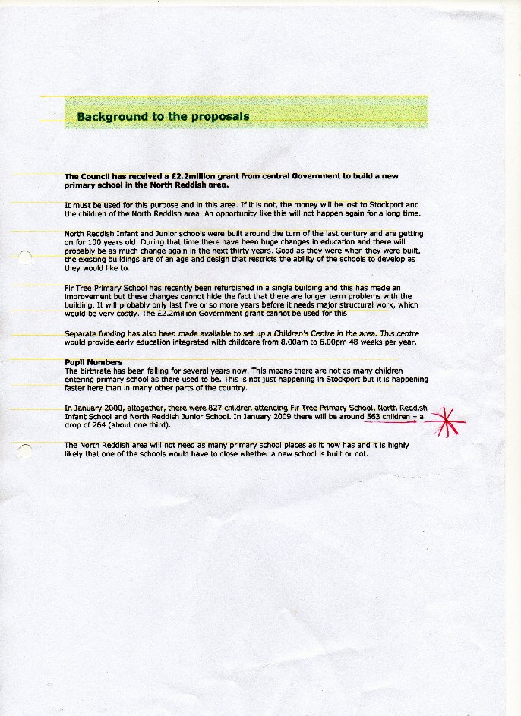

There should have been £650k spent on replacement public playing fields with changing rooms for the disabled. Where are they? Again, it is “vexatious” of me to ask.
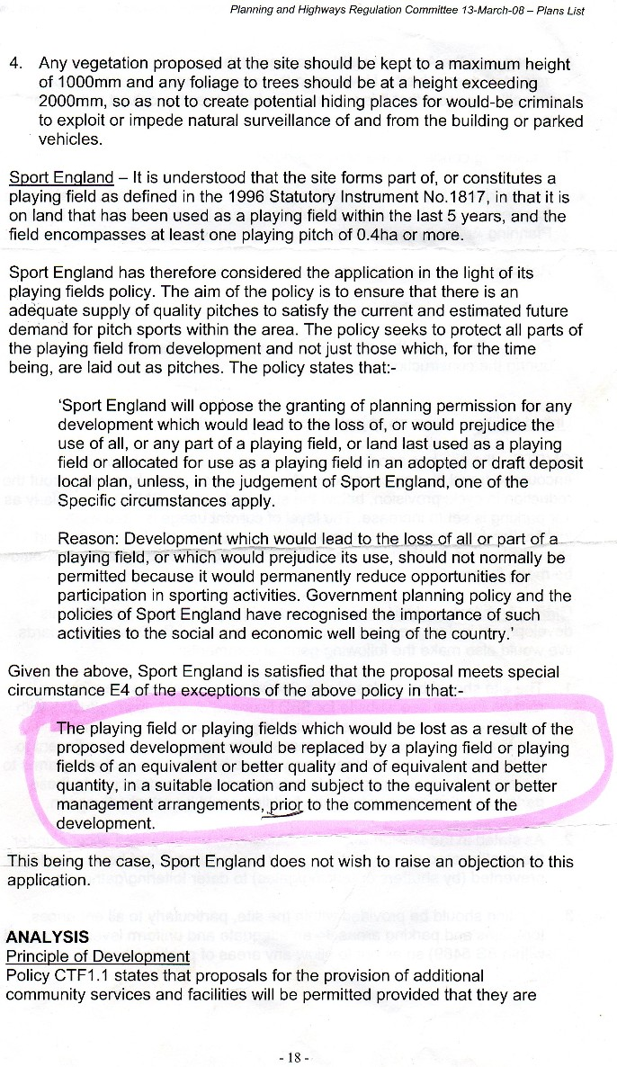
What happened to the money set aside for this? It is “vexatious” to ask.
This again is non-compliance with relevant laws and regulations – a Sport England planning condition.

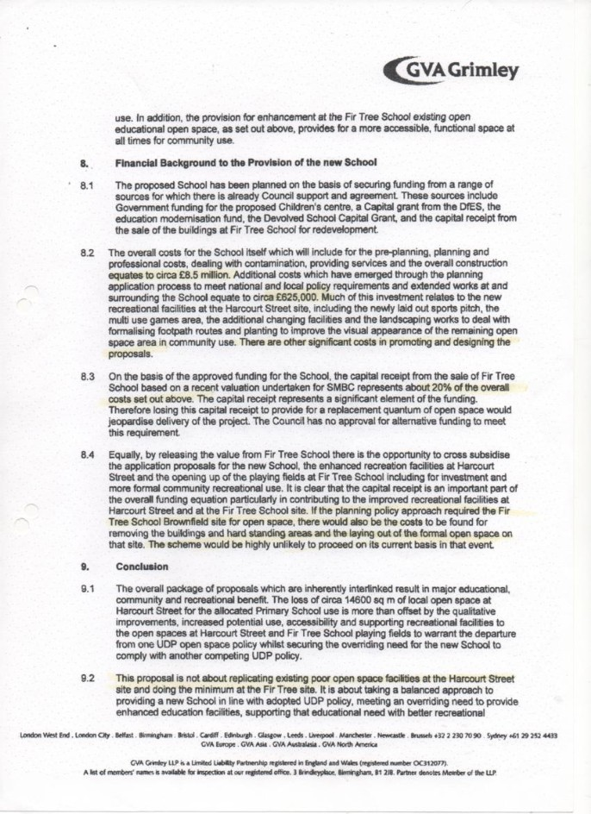

The Environment Agency demanded £200k be spent on drainage at this toxic site over an important aquifer draining into a fishing pond – a site from which the lethal brown asbestos had not been properly removed, but it is “vexatious” to mention this.
https://www.youtube.com/watch?v=b0rCPnP5H9o
Stockport Council is even being taken to court over the drainage issues at the site, but I am “vexatious” for mentioning this.
http://www.manchestereveningnews.co.uk/news/greater-manchester-news/angling-club-threatens-take-stockport-9424885

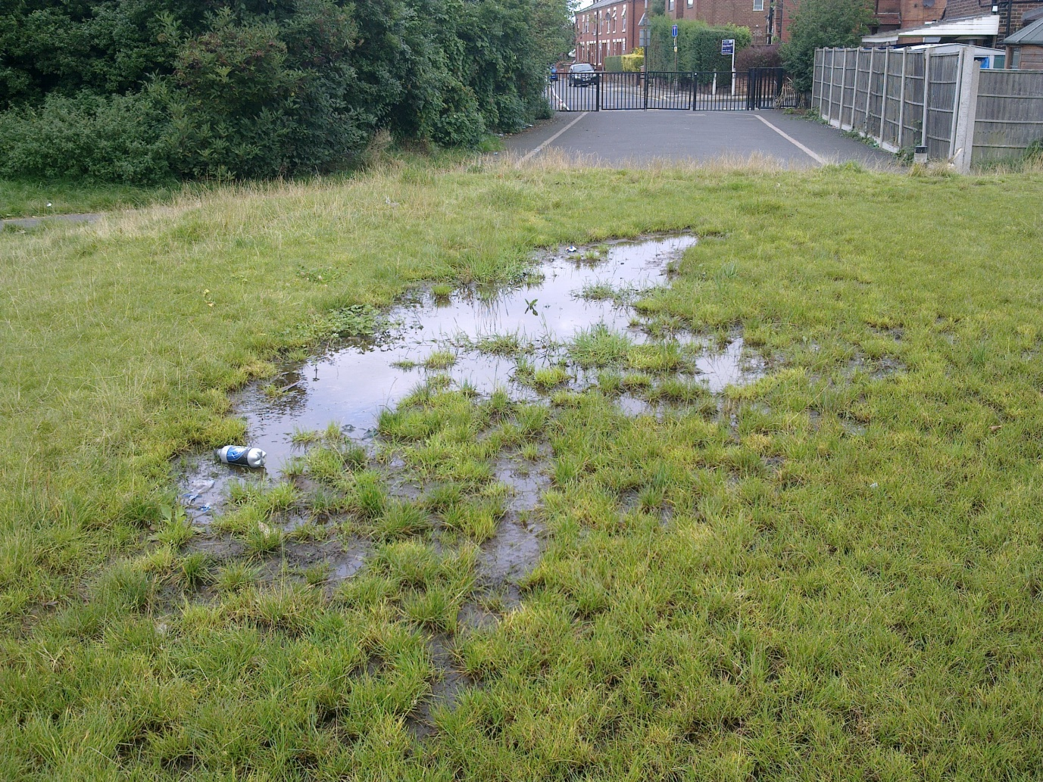

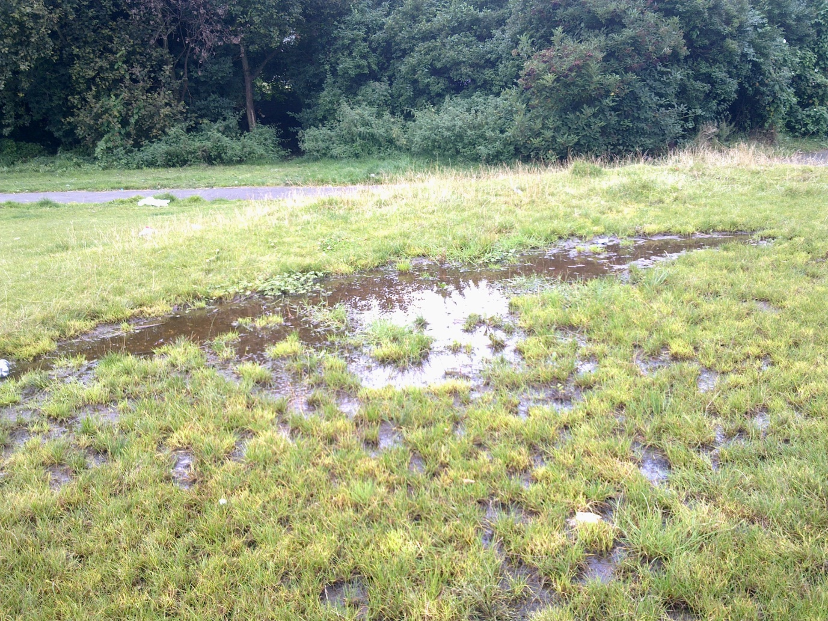
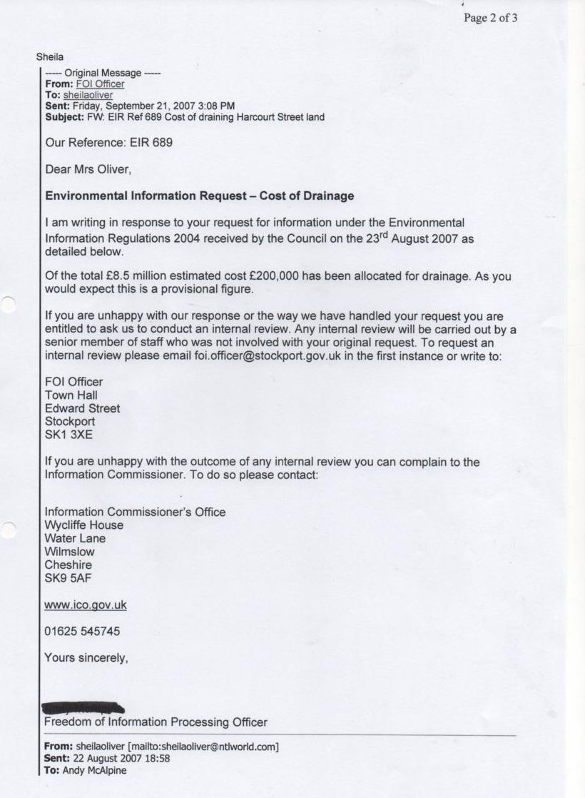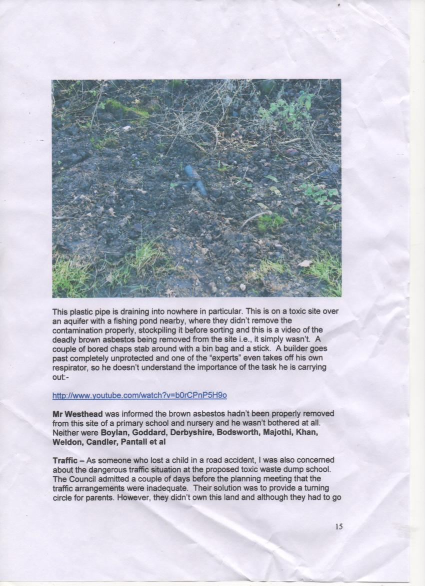

They took public playing fields and recreation ground without holding a public inquiry. Again, this is non-compliance with relevant law and regulations.

And finally, the money.

In October 2005 the school was to have cost £5.5m
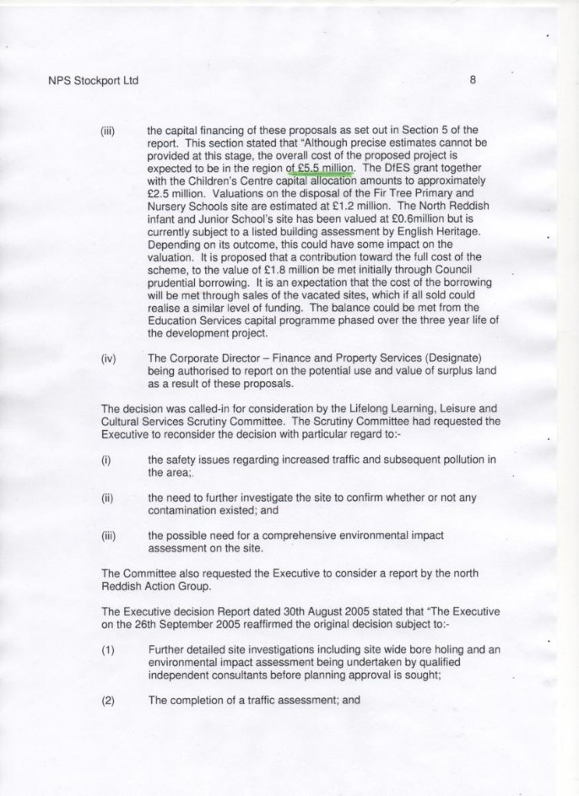
Within a short space of time the cost had risen to £10m. Why? Not to deal with the contamination which they were still pretending didn’t exist.
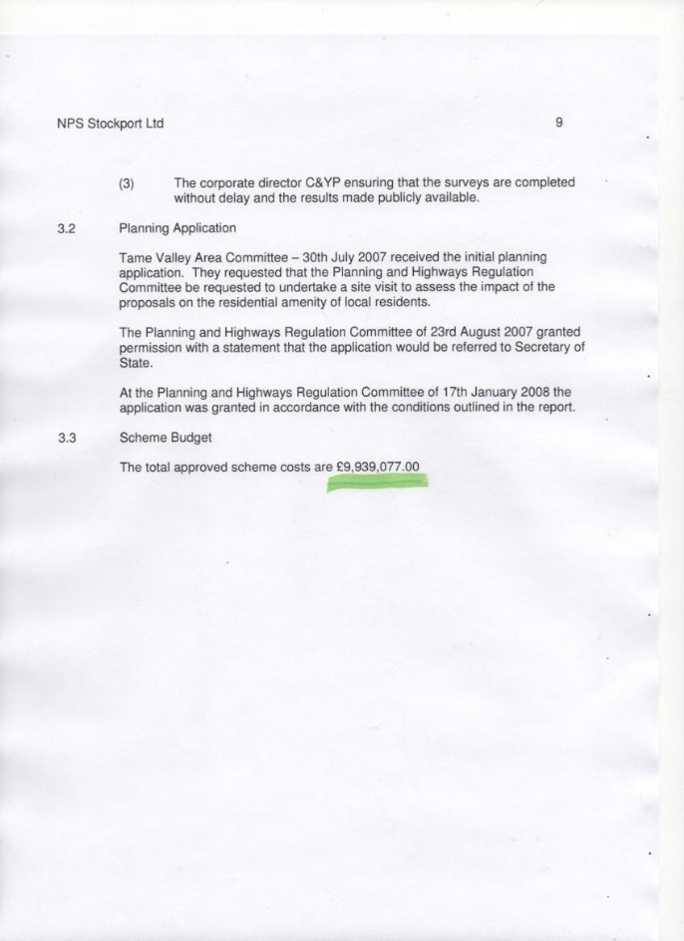

“Vexatious” to ask why as it has been for circa 7 years.

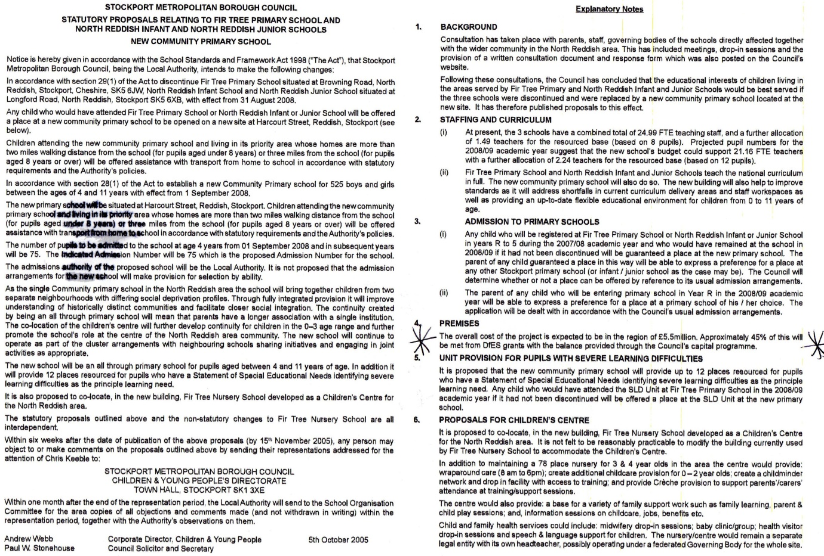

Two months after this the cost had risen from £5.5m to £7.5m. Why? “Vexatious” to ask.

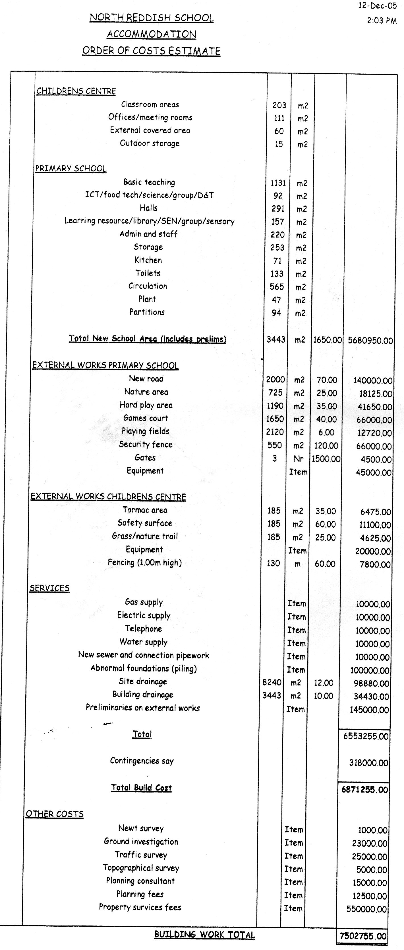
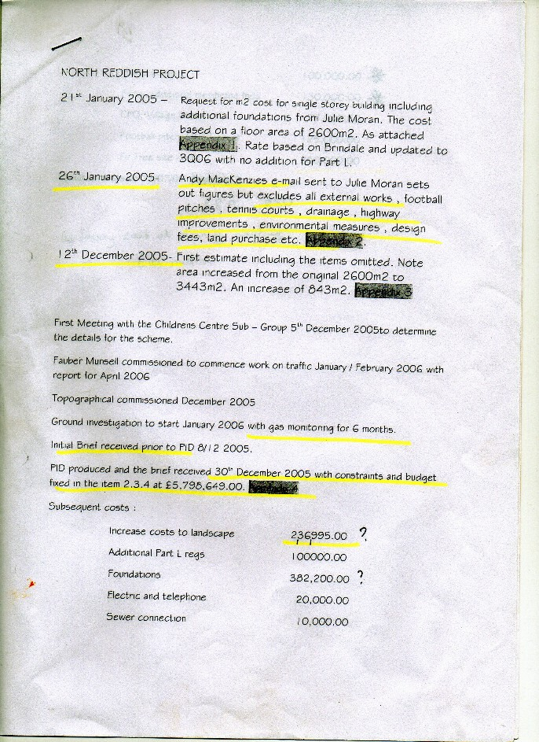
But budget constraints were set at £5,795,649.00.

A few months later it had gone to £8.6m - £2.4m overbudget. As mentioned they were still pretending the site wasn’t contaminated, so it wasn’t for remediation costs. Why is it going up, I asked? Don’t be vexatious, they replied and they still do.

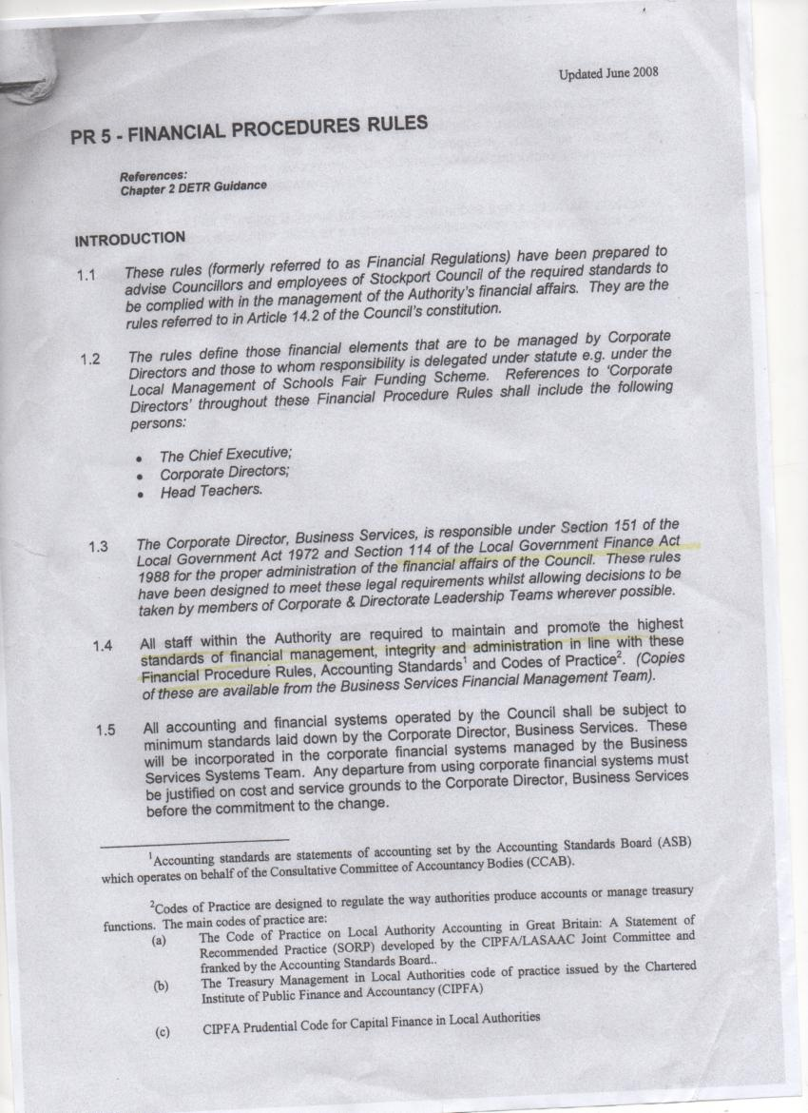
I don’t think any of those involved followed the Council’s Financial Procedure rules. Not much integrity on show in this instance.

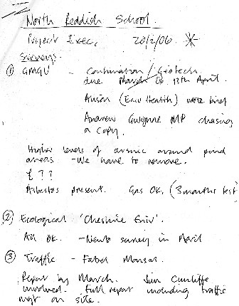
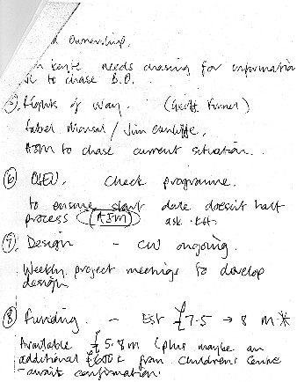

Available funding £5.8m. Cost £8m. Vexatious to question this.

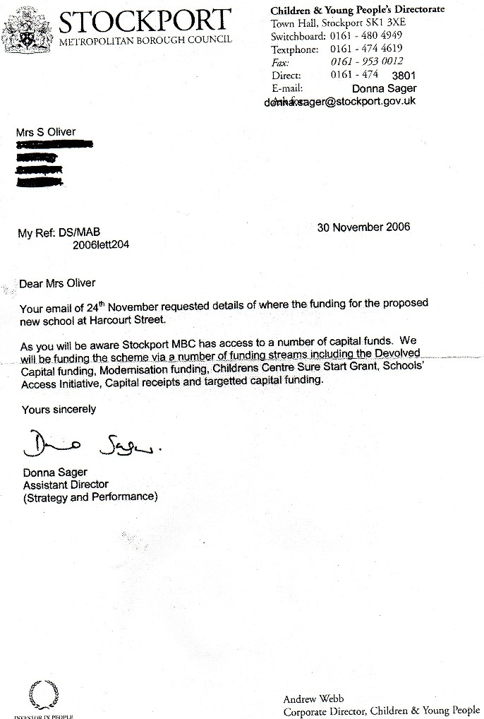

When I was banned from asking any council meeting questions and FOIA questions, I took to questioning the Finance Executive Councillor in the council car park. He finally arranged for this explanation which raises more questions than it answers:
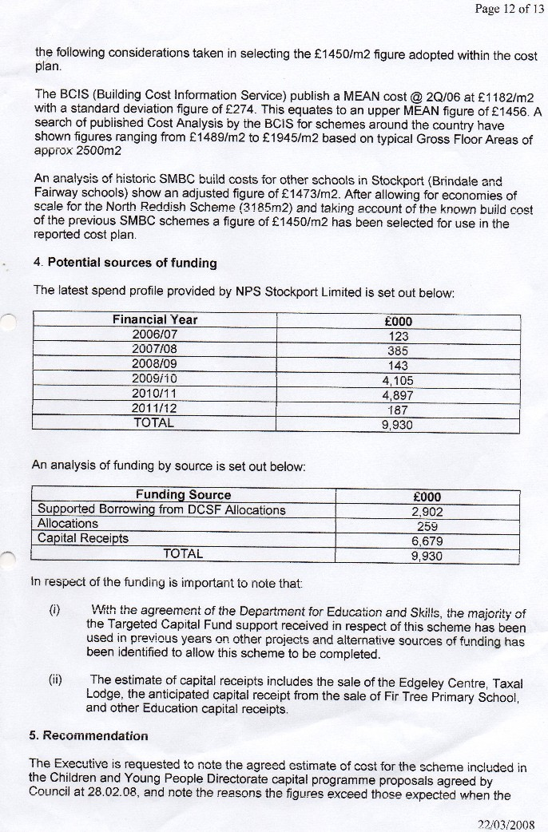

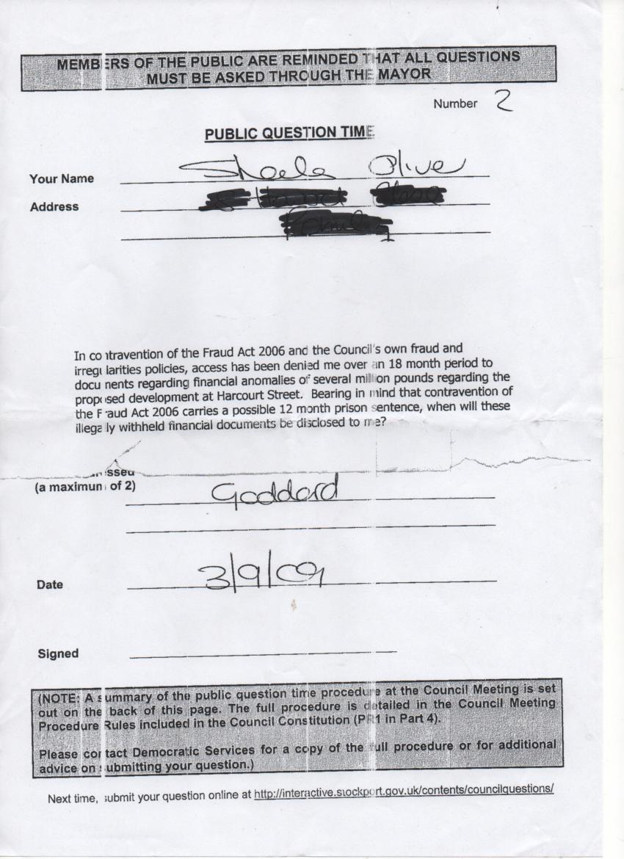

Still being withheld from me at the end of 2015.

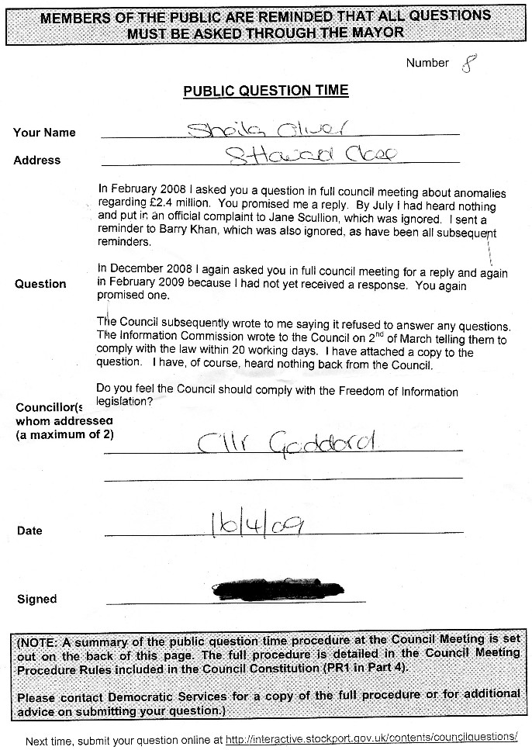

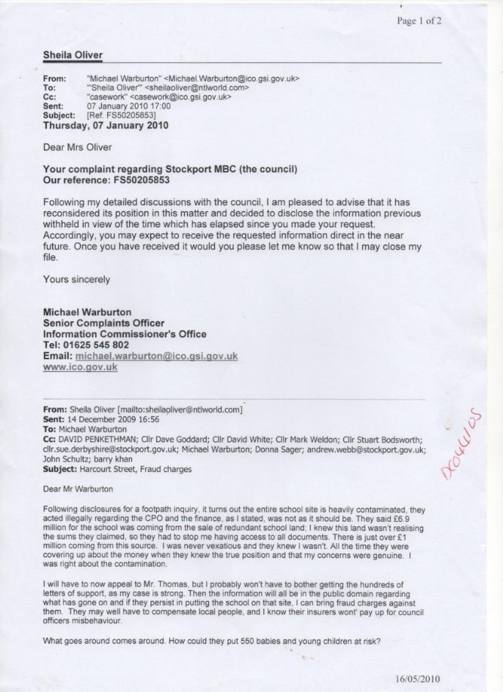

Mr Warburton of the Information Commission told them to respond, but they never did. This is again non-compliance with relevant laws and regulations.

A new school, years down the line, costs far less and is bigger than the toxic waste dump school. Why the financial anomaly? Vexatious to ask.

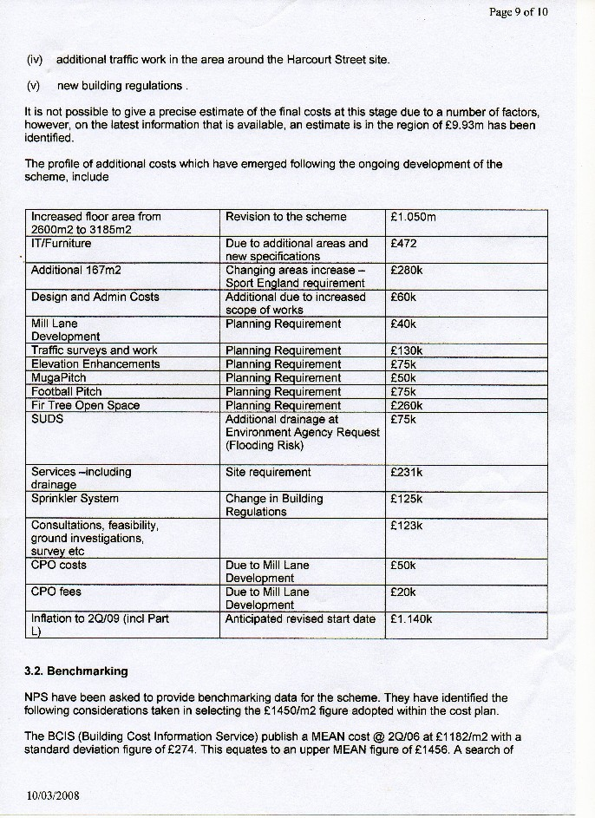

Finally by questioning the Executive Councillor for Finance in the Council car park I obtained the explanations above, which raises more questions than it answers. The school £5.5m school is now £10m.
In this document they explain the size of the school has gone from 2600 m2 to 3185m2. This is a rise of 585m2 and we see the cost they have given is £1450m2. 585 x £1450 = £848,250 and not the £1,050,000 they claim.

No response from the Council’s Finance Director for circa 7 years to my queries about that anomaly.

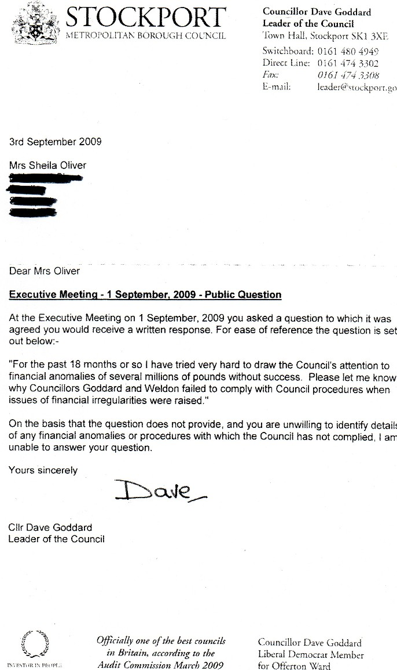
The sort of response from the then Leader of the Council. I had submitted the information to the Council many times and the Information Commissioner had been told what a nuisance I was for doing so.

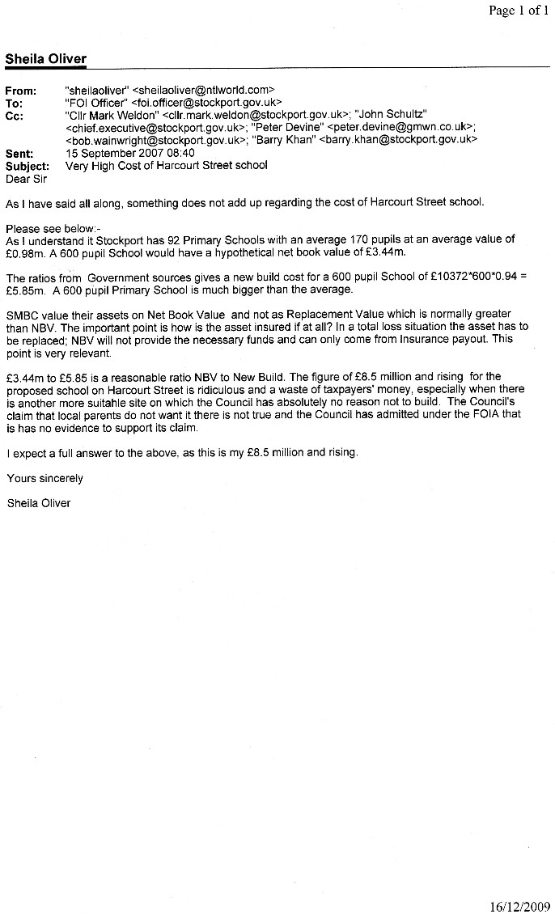
Then £6.9m for this school was to come from the sale of redundant school land.

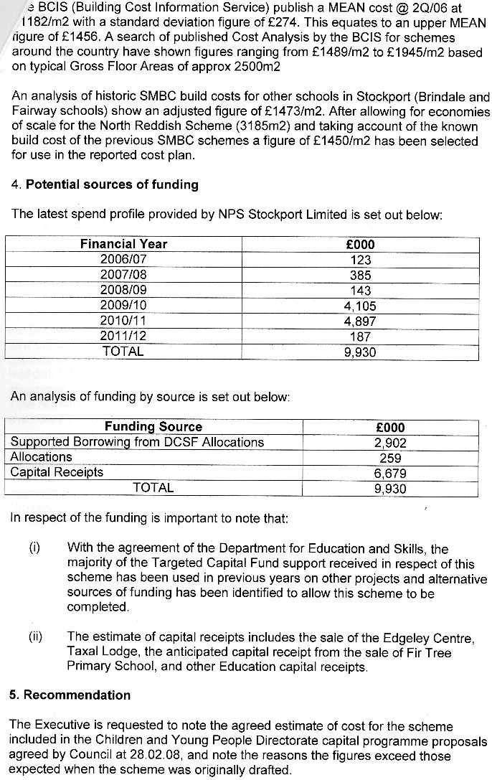
£5m had to be borrowed at the last minute for what was supposed to be a £5.5m project, and it is “vexatious” to question this. Making false claims of vexatiousness under the FOIA and EIR2004 is a criminal offence which carries a prison sentence.
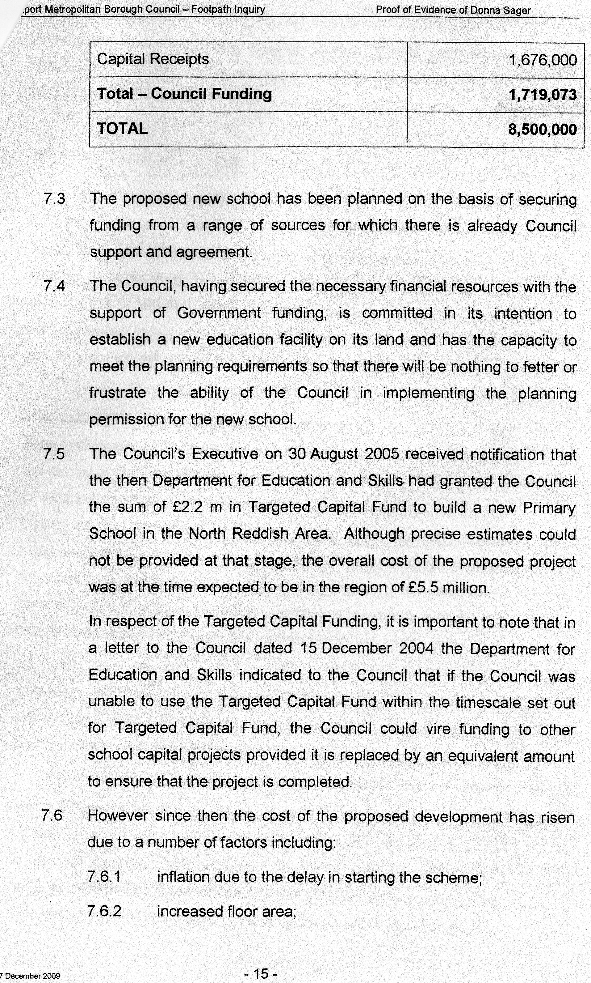
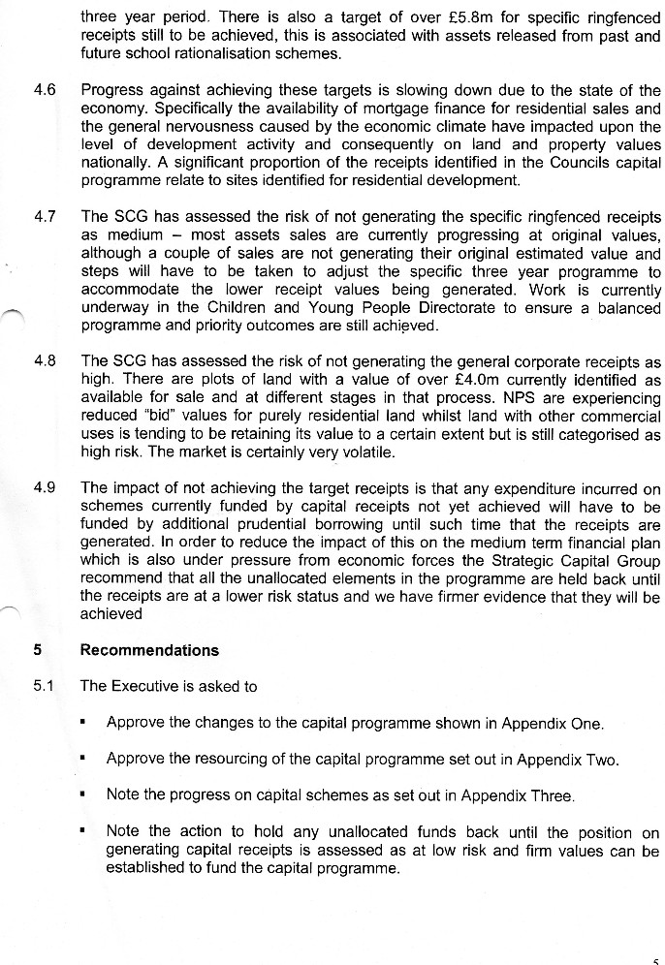

But school land was not selling and I told the Council this (but they knew anyway). Don’t be vexatious, they replied, and they still do.

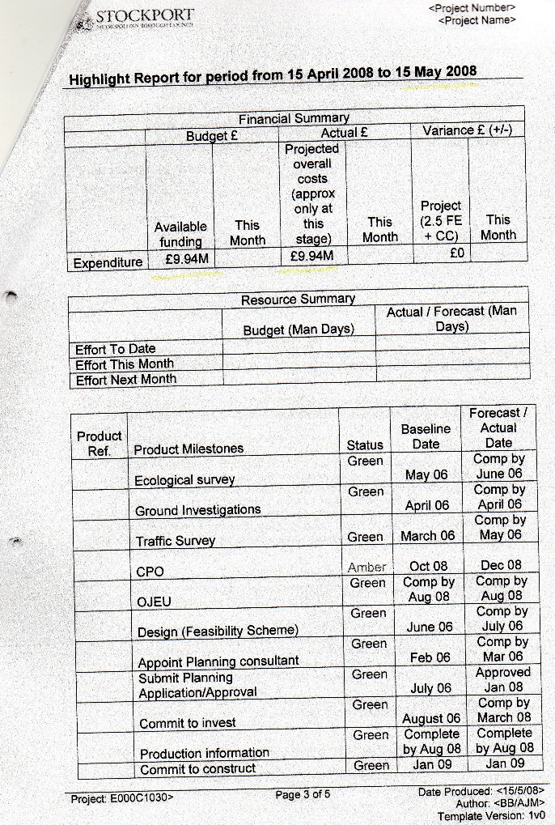

Suddenly, the school was now £10m and mysteriously the multi million pound shortfall had disappeared. How, I asked? Vexatious, they replied, and they still do.

I tried many times to raise this with the District Auditor without any success:
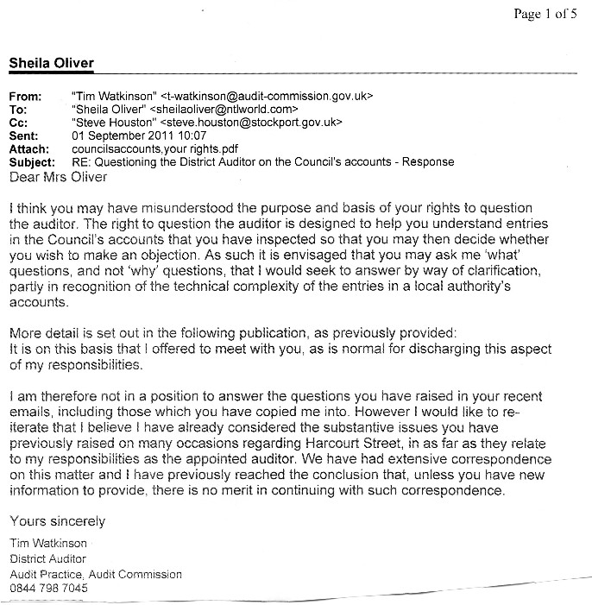

Architects fees for the new school. Seems a lot to me but “vexatious” to question this:

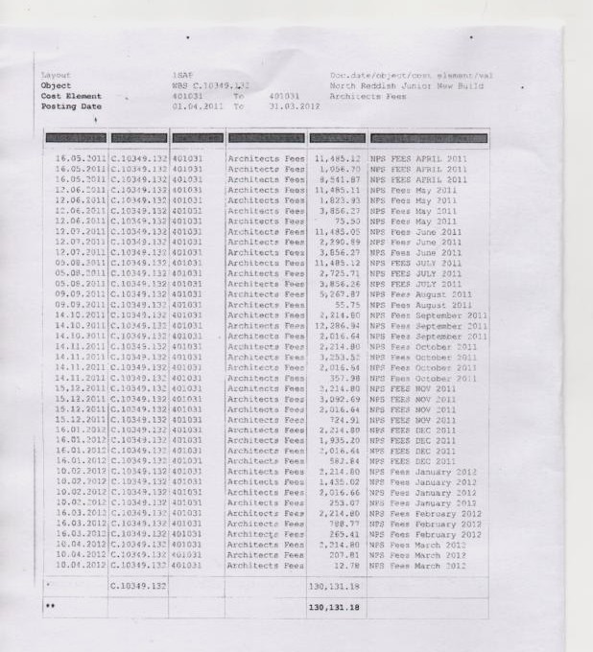

Even the local paper was reporting the skyrocketing costs, but I was “vexatious” to raise the matter.

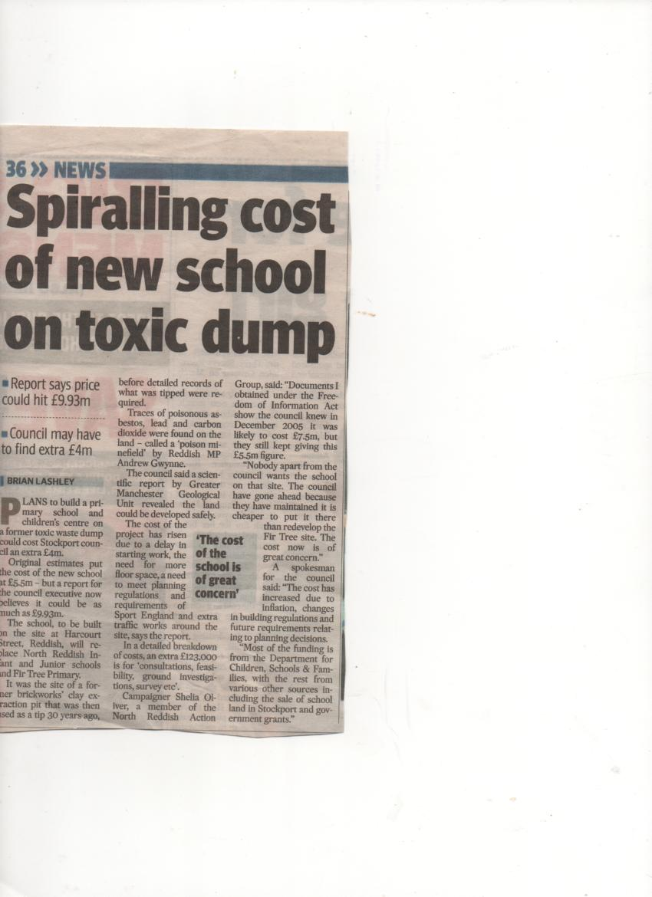

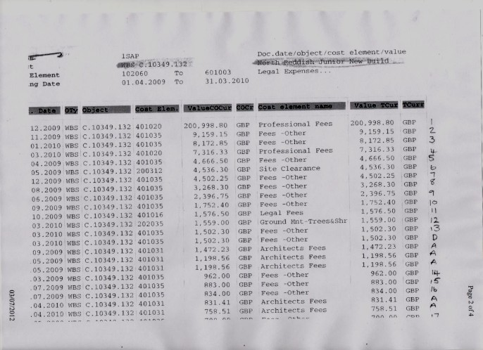

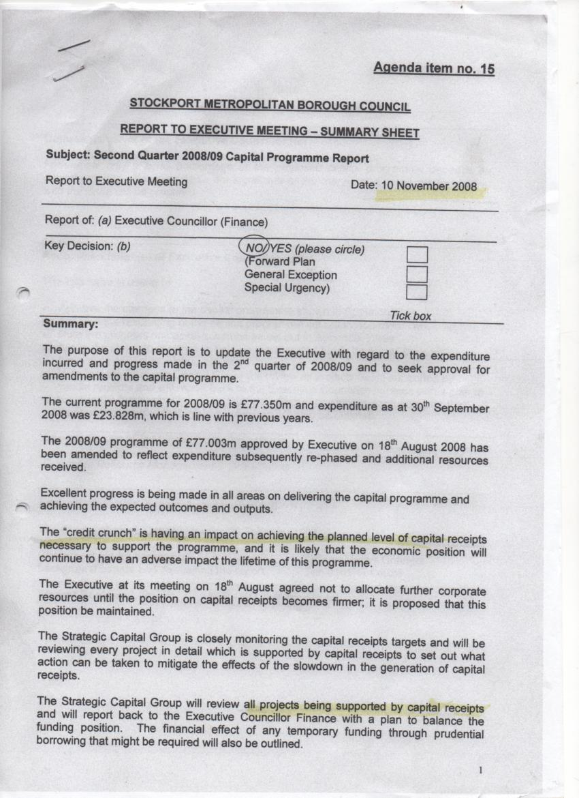

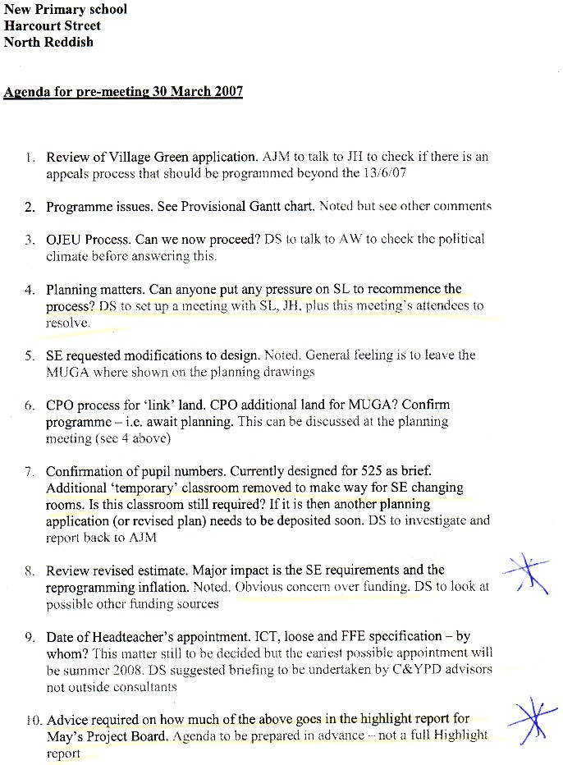

“Obvious concern over funding” said by Donna Sager, who was accusing me of being “vexatious” for questioning the rising costs and “Advice required on how much of the above goes in the Highlight report for May’s Project Board”.
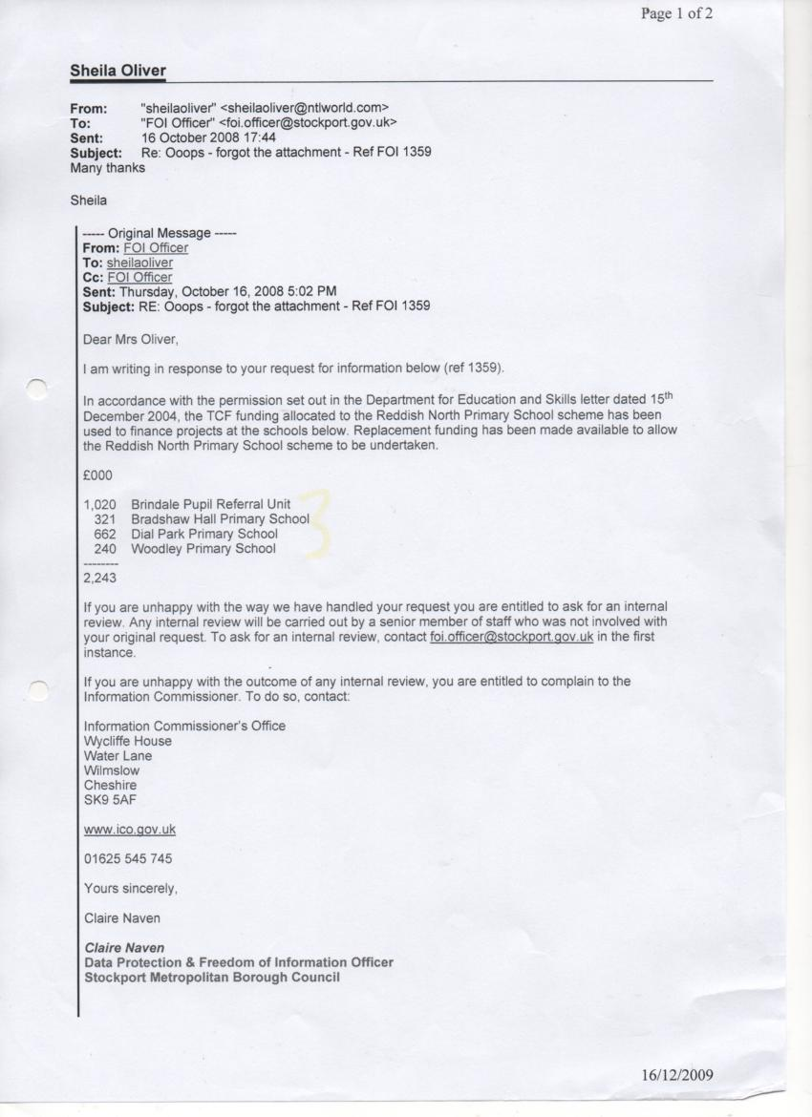

Yours sincerely

Sheila Oliver (Mrs)

c.c. The Prime Minister
10 Downing Street
London
SW1A 2AA

The Chancellor of the Exchequer
11 Downing Street
London
SW1A 2AA

